Chapter 9, Solution 92.

(a) 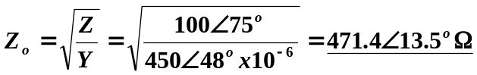

(b)

